***PAAREES PERFUMES***

***DAVIDOFF***

***FOR WOMEN***

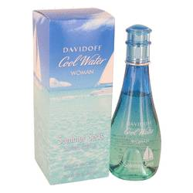

# *Cool Water Summer Seas*

***Description:***

Cool Water Summer Seas by Davidoff Perfume. Davidoff presents a refreshing, feminine fragrance that’s ideal for the summer season, going by the name of Cool Water Summer Seas, because that’s what it feels like. Its accords are aquatic, fruity, and floral. An opener of succulent melon makes a vibrant combination with the flowery heart composed of lily of the valley. You’ll be left with an aromatic last impression as it concludes with the sweet, yet delicate scent of orris root. This perfume can be great for beach parties, sailing trips with friends, or any instance that gives off summer vibes.  
  
Cool Water Summer Seas is part of a limited edition summer collection from Davidoff. Zino. the man responsible for creating the Swiss family-owned business, had a zeal for the finer things in life and wanted to share that with others. Today, the company sells numerous products faithful to his sybaritic view. Among these are fragrances, cigars, coffee, cognac, watches, pens, eyewear, and leatherwear.